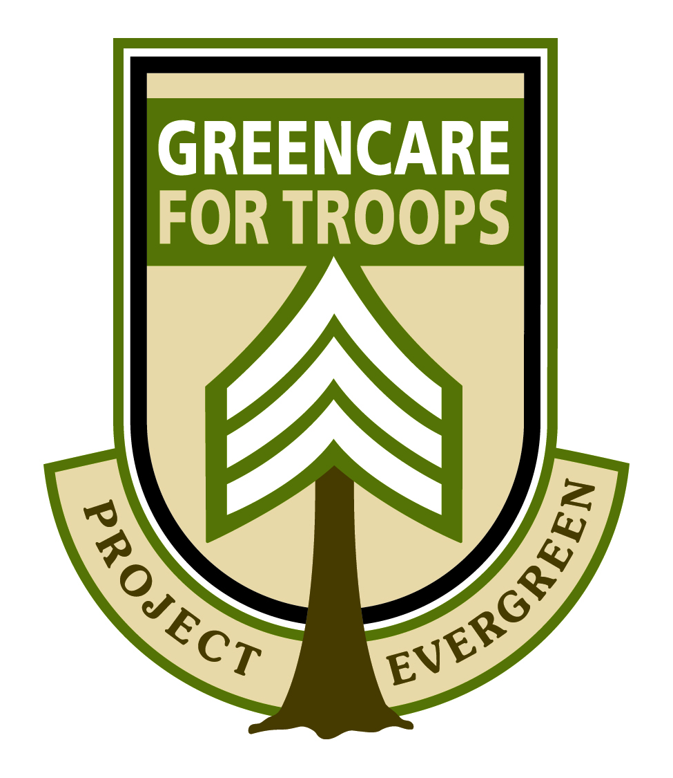
National GreenCare for Troops Awareness Week
June 11-17, 2017
A managed lawn and yard provides vital space for military personnel and veterans to recover and re-connect with their families. Delivering the services needed to create the green spaces that provide military families and post 9/11 service-connected wounded/disabled veterans with peace of mind and freedom to heal is what Project EverGreen’s GreenCare for Troops is all about.
GreenCare for Troops provides complimentary basic lawn care and landscape services to these deserving individuals. From back yards for service dogs to run in to green gardens for disabled veterans to reflect in, thriving lawns, trees and plants go beyond the aesthetics; they provide individuals with the ability to actively participate in creating a greener, healthier, cooler Earth.
As the program celebrates its 11th year Project EverGreen recognizes National GreenCare for Troops Awareness Week. To help our volunteers promote their participation in the program we have created a Promotional Tool Box volunteers can use to promote their participation and mission of the initiative.
We encourage you to share information about your involvement with GreenCare for Troops with the local media, civic and veterans groups in your community.
Project EverGreen would also like to recognize The Toro Company and Nufarm for their support of the program.
Thank you again for your participation and support of this valuable program.

Cindy Code Dan Carrothers
Executive Director President
Project EverGreen Project EverGreen

GreenCare for Troops
Promotional Tool Box Index

- How To Promote Your Company’s
Participation in GreenCare for Troops
- DIY Press Release
- GCFT Logos
- Social Media Tags/Suggested Posts/Logos
- GCFT Awareness Week Infographic
- Media Talking Points and Facts & Figures
- Tips for Earning Media Coverage
- 10 Benefits of Green Spaces
- How To Order Your GreenCare for Troops Truck Sticker

Follow Project EverGreen on Social Media
Twitter
@ProjectEvrGreen
Facebook
Project EverGreen
You Tube
Project EverGreen

How to Promote Your Company’s
Participation in GreenCare for Troops
Your commitment to being a GreenCare for Troops volunteer deserves recognition and Project EverGreen offers the following tips to make sure your good work on behalf of military families and post 9/11 service-connected wounded/disabled veterans is recognized in your company and in the community.
Engage Your Employees
- Share the news with your employees via email or text
- Promote your involvement in the breakroom or employee newsletter
- Have your crew managers share the news during meetings and training sessions
- Have your employees update their email signature line. For example: “YOUR COMPANY NAME Is A Proud Project EverGreen GreenCare for Troops Volunteer”
Take Advantage of Social Media
- Publicize your involvement on social media including Facebook, Twitter, LinkedIn, etc. (see Social Media Tags & Suggested Posts)
- Change your profile picture and cover photo to the GCFT logo (included in your Promotional Tool Box)
- Ask employees to share news of your involvement via social media and “like” or retweet related posts from your company outlets
- Publish a blog post announcing your involvement with GreenCare for Troops
Update Your Website
- Place the GreenCare for Troops anniversary logo and infographic (included in the Promotional Tool Box) on your home page
- Like and follow Project EverGreen’s Facebook (Facebook/Project EverGreen) and Twitter (@ProjectEvrGreen)
- Promote your involvement in GreenCare for Troops on the About Us or Community page
- Create a separate GreenCare for Troops page on your website and include the logo and photos of your crews helping military families or veterans
Promoting To Your Community
- Share a press release (see DIY Press Release) with customers, local media and related green industry organizations in your state
- Share your story with local TV, radio and newspapers (see Tips for Earning Media Coverage)
- Add the GreenCare for Troops logo to your marketing collateral, letterhead, vehicle signage, etc.)
- Request a complimentary GreenCare for Troops truck logo (see How to Order Your
GreenCare for Troops Truck Sticker)
- Have a banner made to hang in your office or display at industry/community events

NEWS RELEASE FOR IMMEDIATE RELEASE
<INSERT COMPANY LOGO>
Contact:
<First Name><Last Name>
<Company Name>
<Phone Number> <Email Address>
[Company Name] Celebrates National GreenCare for Troops Awareness Week to Support Local Military Families
June 11-17, 2017 Is National GreenCare for Troops Awareness Week
[City], [State] (Date) – To raise awareness of the growing need of families of deployed military personnel and post 9/11 service-connected wounded/disabled veterans who need help with basic lawn care and landscape services, Project EverGreen recognizes June 11-17, 2017 as National GreenCare for Troops Awareness Week.
[Company Name] of [Local Town Name] is proud to participate in the observance of a program that provides families of currently deployed military personnel as well as wounded and post 9/11 service-connected wounded/disabled veterans with complimentary lawn care and landscape services.
Studies have shown that access to well-maintained green spaces provide children with a safe place to play, exercise and compete, and connect with their community. Maintained green spaces also increase property values and provide individuals with the ability to actively participate in creating a greener, healthier, cooler Earth
[Company Name] is one of thousands of lawn care and landscape professionals across the country that donates its services and time to ease the burden on military families or disabled and wounded veterans needing assistance.
“We’re proud to support the GreenCare for Troops program and lend a hand to help our local military families and veterans who already carry so much on their shoulders, the last thing they should be worrying about is fertilizing or mowing their lawn,” said [Name and Title] of [Name of Company]. “It’s also our way of providing a safe and serene setting for families to unwind and enjoy.”
Since GreenCare for Troops was launched in 2006, more than 11,000 military families across the country have registered for the program and more than 6,000 lawn and landscape contractors have volunteered to provide more than $8 million in in-kind services. The program is supported by The Toro Company and Nufarm.
[Company Name] is urging interested military families and veterans to register for participation in the GreenCare for Troops program by calling Project EverGreen at 888.611.2955 or registering online at www.projectevergreen.org.
# # #

About [Company Name]

[Add a brief paragraph here about your company, what your principal business is, where you are located and other pertinent details.]

National GreenCare for Troops
Social Media Tags & Suggested Posts
National GreenCare for Troops Awareness Week promotes and raises awareness for the initiative that provides complimentary lawn care and landscape services to families of currently deployed military personnel as well as post 9/11 service-connected wounded/disabled veterans.
During National GreenCare for Troops Awareness Week, we encourage you to devote your company’s social media efforts to raise awareness for a program that helps thousands of our nation’s heroes.
Use the hashtag #GCFT2017 in all posts and interactions on Twitter and Facebook, and don’t forget to share Project EverGreen’s Facebook posts and re-tweet posts from @ProjectEvrGreen.
Also feel free to update your company’s Facebook cover photo and Twitter background with the GreenCare for Troops logo that can be found on the GCFT volunteer page on our website.
GreenCare for Troops “Did You Know?” Facebook Posts
- Did you know GreenCare for Troops volunteers have delivered more than $8 million in lawn care and landscape services to the military families and post 9/11 service-connected wounded/disabled veterans since the program started in 2006? Add to that total and register to be a volunteer today at www.ProjectEverGreen.org #GCFT2017 #ProjectEverGreen
- Did you know that #GreenCareforTroops relieves stress and gives peace of mind for military families and post 9/11 service-connected wounded/disabled veterans? Register to be a volunteer today at www.ProjectEverGreen.org #GCFT2017 #ProjectEverGreen
- Did you know Project EverGreen’s GreenCare for Troops has volunteers in all 50 states and was recognized by the White House’s Joining Forces Initiative for serving military families? Register to be a volunteer today at www.ProjectEverGreen.org #GCFT2017 #ProjectEverGreen
- Did you know GreenCare for Troops is in its 11th year serving military families and post 9/11 service-connected wounded/disabled veterans? Join our ranks and register today to be a volunteer at www.ProjectEverGreen.org #GCFT2017 #ProjectEverGreen
- Did you know that since 2006, more than 11,000 military families and 6,000 volunteers across the country have registered to provide lawn and landscape services? Lend your time and talents and register today at www.ProjectEverGreen.org #GCFT2017 #ProjectEverGreen
- Did you know there are 3.6 million veterans with a service-connected disability needing assistance with day-to-day household and lifestyle assistance services? Become a hero to our nation’s heroes and register to be a volunteer today at www.ProjectEverGreen.org #GCFT2017 #ProjectEverGreen
Twitter Posts

- Great cause. Great people. What’s not to like? Get involved. #GCFT2017 @ProjectEvrGreen @TheToroCompany @NufarmUSTurf
- 3.6 million veterans need help with lifestyle assistance services. Can you help? #GCFT2017 @ProjectEvrGreen @TheToroCompany @NufarmUSTurf
- 6,000 volunteers have already registered. What are you waiting for? #GCFT2017 @ProjectEvrGreen @TheToroCompany @NufarmUSTurf
- Are you up for the #GreenCare for Troops challenge? #GCFT2017 @ProjectEvrGreen @TheToroCompany @NufarmUSTurf
- Giving back to our heroes’ one lawn and landscape at a time. #GCFT2017 @ProjectEvrGreen
- Giving is far more rewarding than receiving. #GCFT2017 @ProjectEvrGreen @TheToroCompany @NufarmUSTurf
- 11,000 military families have registered for services and more are coming. Can you help? #GCFT2017 @TheToroCompany @NufarmUSTurf
- Honor a military family and volunteer for #GreenCareforTroops #GCFT2017 @ProjectEvrGreen @TheToroCompany @NufarmUSTurf
- Don't forget to follow @ProjectEvrGreen for the latest post on #GreenCareforTroops #GCFT2017 @TheToroCompany @NufarmUSTurf
- $8 million in lawn care and landscape services provided since 2006. Can we do more? #GCFT2017 @TheToroCompany @NufarmUSTurf
National GreenCare for Troops Awareness Week
Media Talking Points and Facts & Figures
National GreenCare for Troops Awareness Week (June 11-17, 2017) is meant to raise awareness for the program that provides no charge lawn care and landscape services to families of deployed military personnel as well as post 9/11 service-connected wounded/disabled veterans. Please take a moment to read through these talking points describing the GreenCare for Troops program prior to contacting the media. When doing an interview, it is a good idea to have a copy with you for reference.
What is the GreenCare for Troops program?
GreenCare for Troops is a nationwide outreach program sponsored by Project EverGreen and our company to care for lawns and landscapes of families of deployed military personnel as well as post 9/11 service-connected wounded/disabled veterans.
What is National GreenCare for Troops Awareness Week?
National GreenCare for Troops Awareness Week a national observance of the program and our goal is to raise awareness with military families and post 9/11 service-connected wounded/disabled veterans about the services available, as well as recruit additional volunteers to provide these valuable services.
Who is Project EverGreen?
Project EverGreen is a national non-profit group that engages individuals, businesses and communities to create a greener, healthier, cooler Earth. This is done through the creation, renovation and revitalization of yards, parks, recreational playing surfaces and other green spaces that represent the lungs of the community and result in healthier, happier people.
How can military families interested in participating apply for the program?
Families may register online at the Project EverGreen website at www.ProjectEverGreen.org or by calling Project EverGreen’s Ki Matsko at 888.611.2955 or e-mail kimatsko@projectevergreen.com
What other types of programs does Project EverGreen sponsor?
Project EverGreen currently manages the following programs: SnowCare for Troops, “Healthy Turf. Healthy Kids.” ™ and the Environmental Communicator of the Year Award.
What are the environmental benefits of maintaining green spaces?
When cared for properly, healthy lawns and landscapes do numerous good things for the environment, including reducing erosion, filtering pollutants from water, providing natural cooling and providing cleaner air. For more information on the environmental benefits of maintained lawns and landscapes, visit www.ProjectEverGreen.org
What are the economic benefits of maintaining green spaces?
Studies show that consumers value a landscaped home up to 11 percent higher than its base price. Design sophistication, plant size and plant material type are the most important factors in designing a landscape that will maintain or increase a home’s value. For more information on the economic benefits of maintained lawns and landscapes, visit www.ProjectEverGreen.org
What are the lifestyle benefits of maintaining green spaces?
Among the many benefits of well-maintained landscaping are increased community appeal, lower crime rates and increased privacy and tranquility. Plants lower blood pressure, reduce muscle tension related to stress, improve attention, and reduce feelings of fear and anger or aggression. For more information on the lifestyle benefits of maintained lawns and landscapes, visit www.ProjectEverGreen.org
Questions you may be asked that you should prepare your own talking points for:
- How many family’s lawns and landscapes are you currently caring for?
- What services do you perform? How many families will you accept?
- How can families register to receive services?
GreenCare for Troops Facts & Figures
- 1 - White House Joining Forces Initiative Award
- 11 – The numbers of years GreenCare for Troops has been helping families of deployed military personnel
- 50 – States in which there are registered military families and volunteer contractors
- 2006 – The year GreenCare for Troops was launched
- 6,000 – Number of volunteer contractors that have registered to provide services through GreenCare for Troops
- 11,000 – Number of military families who have registered for GreenCare for Troops since program’s inception
- 150,500 – Estimated number of U.S. military personnel deployed overseas
- 3.6 Million – Number of veterans with a service-related disability needing assistance with day-to-day household and lifestyle assistance services
- $8 million – Estimated value of in-kind services provided to military families and veterans through GCFT since the program’s inception
Tips for Earning Media Coverage
Create A Story You Could See A Reporter Covering Before Your Contact Them
Reporters need more than just a big idea to sell a story to their editor or assignment editor. Think like a journalist and determine what angle is most appealing, who can they interview and what information will they need to make the story more colorful and interesting? Having this information before you call or email a reporter will make it easier for them and their editor and producer to “yes.”
Make Reporters Care About Your Pitch
Make sure your email or voice mail message leaves a good first impression on the reporter or assignment editor. Cut to the chase quickly and use bullet point summaries when sharing information. Avoid long-winded or flowery messages but do include emotion about the mission and positive impact GreenCare for Troops has on both recipients and volunteers.
Be Easy To Work With
There are many organizations seeking coverage for their projects and events so make it easy for reporters to work with you. Be flexible on interview times or providing background when the reporter is doing their research. Don’t overdo it with emails and anticipate a reporter’s questions ahead of time so you can be ready to respond.
Pick Up The Phone
Don’t rely solely on email to contact a reporter or assignment editor. Yes, they do appreciate the convenience of email in sharing information but there is nothing wrong with picking up the phone and giving your pitch. Make your call quick and time it right – a few hours after you send your email is good. Also make sure to call the right reporter whose beat focuses on veterans or military issues, non-profits or the environment.
Send Thank You Notes
Make sure to follow up with a quick thank you email to the reporter after the story runs and stay in touch with that reporter. Make yourself an expert resource the reporter can turn to when if a story comes up on lawn care, landscaping or green spaces.
Remember, there is never any guarantee of media coverage but following these steps will help get you on the right path to having your GreenCare for Troops efforts earn coverage.

Source: Information adapted from an article that appeared in Ragan’s PR Daily
10 Benefits of Green Spaces
Green spaces provide communities with a number of economic, lifestyle and environmental benefits. Numerous studies have shown that green spaces contribute positively to the health and well-being of both children and adults. Project EverGreen proudly supports the ongoing development and renovation of green spaces in communites across the United States.
- Children can burn up to 100 calories in one hour of active play and more during athletic competition.
- Studies have shown that children who are more physically active and have access to athletic green spaces demonstrate higher academic performance in school.
- Green spaces, athletic fields and playing surfaces are gathering places that create close-knit communities, improve well-being, increase safety and help develop a lifelong connection to green spaces.
- One tree removes enough carbon dioxide from the air and releases enough oxygen for a family of four to breathe for a day.
- Green spaces are therapeutic and improve the quality of life as studies illustrate that hospital patients whose rooms overlook landscapes recover faster and require less pain medication than patients without a view of nature.
- Landscaping around your home can reduce noise by up to 50 percent.
- A well-maintained landscape can add up to 15 percent to a property's value when selling a home and landscaping can speed the sale up by as much as six weeks.
- Planting shade trees lowers attic temperatures by as much as 40 degrees and landscaping (plants, shrubs, trees) around a structure reduces air conditioning costs by 50 percent
- Did you know that properly maintained shrubs, plants and lawns are environmental heroes? Because of their filtering capabilities, plantings prevent soil erosion, filter contaminants from rainwater, and absorb dust and dirt.
- Eight average-sized front lawns have the cooling effect of 70 tons of air conditioning.

How to Order Your
GreenCare for Troops Truck Sticker
Show your GreenCare for Troops Initiative pride and promote your company's commitment to serve families of deployed military personnel and post 9/11 service-connected wounded/disabled veterans with a GreenCare for Troops truck sticker.
To receive two (2) free vehicle stickers (shown at right) current volunteers need to update their online profile at http://bit.ly/1KCGsoS . Volunteers need to log on as a "New User" and select a password to match the email address on file.
If you have any questions on updating your profile please contact Project EverGreen's Ki Matsko at 888.611.2955 or kimatsko@projectevergreen.com

Presenting Partner

Platinum Partner
